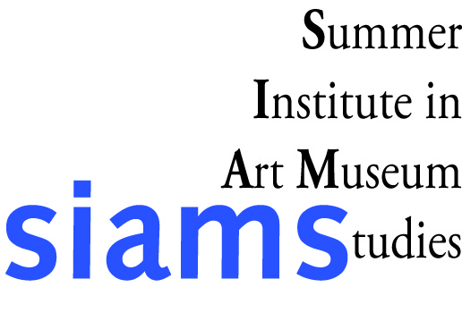
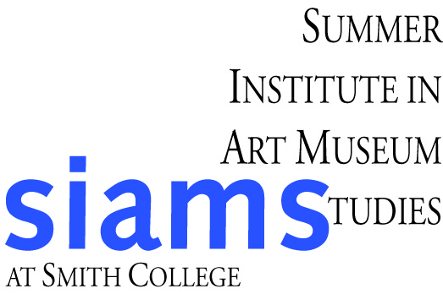
Summer Institute in Art Museum Studies

Recommendation Form

Materials must arrive at Smith by March 9, 2012.

The individual named below is applying to the Summer Institute in Art Museum Studies at Smith College. SIAMS is an intensive, hands-on, six-week, co-educational, exploration of art museums and museum work for undergraduates and recent grads. This recommendation is to be used only for the purpose of selecting participants in the Summer Institute of Museum Studies and does not become part of the applicant’s permanent file. Feel free to continue on the reverse or to submit your response on a separate sheet, if you wish.

Name of Applicant:

Name, Affiliation, and Contact Information of Recommender:

How long have you known the applicant and in what context?

The selection committee requests your comments on the applicant’s academic ability, interest in art history and art museums, capacity for teamwork, maturity, adaptability and any other factors that may be pertinent.

Please mail in a sealed envelope, signed across the flap, to:
Summer Institute in Art Museum Studies, Smith College Museum of Art, Elm Street at Bedford Terrace, Northampton, MA 01063

